

**Master’s Degree in Computer Science**

**Academic year 2023/2024**

**WEB INFORMATION MANAGEMENT**

Usability analysis of

[**https://www.rottentomatoes.com/**](https://www.rottentomatoes.com/)

website



Author: **Michael Amista’**

Student ID: **2122865**

Period of analysis: **January-February 2024**

**Contents**

1 Introduction 5

2 Preliminary analysis 5

2.1 What is Rotten Tomatoes? 5

2.2 Domain name 6

2.3 SERP positioning 6

3 Homepage 8

3.1 Informative axes 8

3.1.1 WHERE did the user arrive? 9

3.1.2 WHO is behind the website? 9

3.1.3 WHY should the user stay? 10

3.1.4 WHAT does the site offer? 10

3.1.5 WHEN? Is the website up to date? 11

3.1.6 HOW does the user arrive where he wants? 11

3.2 Menu 12

3.3 Searching 13

3.4 F-shape scanning 15

3.5 Scrolling 17

3.6 Text 18

3.7 Visual metaphors 18

3.8 Asking for personal data 20

3.9 Video player 21

4. Internal pages 22

4.1 Movies and TV shows 23

4.1.1 Informative axes 23

4.1.1.1 Mandatory axes 24

4.1.1.2 Optional axes 24

4.1.2 Structure and functionalities 25

4.1.3 Visual metaphors 25

4.2 Movie 27

4.2.1 Mandatory informative axes 27

4.2.2 Optional informative axes 28

4.2.3 Structure and functionalities 29

4.2.4 Visual metaphors 30

4.3 TV show 32

4.3.1 Mandatory axes 32

4.3.2Optional axes 33

4.3.3 Structure and functionalities 33

4.4 News 35

4.4.1 Mandatory informative axes 35

4.4.2Optional informative axes 36

4.4.3 Structure and functionalities 37

4.5 Handle of 404 error 38

5. Final evaluation 40

**Figures**

Figure 1: SERP overview for "rotten" (22/01/2024) 7

Figure 2: Homepage 8

Figure 3: Footer 9

Figure 4: News section in the homepage 11

Figure 5: Menu 12

Figure 6: Usability problem in the menu 12

Figure 7: Search functionality in the top menu 14

Figure 8: Search functionality in NEWS page 14

Figure 9: F-shape scanning on the homepage 16

Figure 10: Instance of visual metaphors in the homepage 19

Figure 11: Cookie banner for the first visit 20

Figure 12: Video player 21

Figure 13: Movies/TV shows webpage 23

Figure 14: Visual metaphors explanation on filter options 26

Figure 15: Movie webpage 27

Figure 16: Visual metaphors explanation in a movie page 31

Figure 17: TV show webpage 32

Figure 18: News webpage 35

Figure 19: 404 error under the "rottentomatoes.com" domain 38

Figure 20: 404 error under the "editorial.rottentomatoes.com" domain 39

# **1 Introduction**

Over the years Internet has become a powerful and useful tool able to connect information from different sources and providing it to everyone. The number of websites is consistently increasing day by day due to the high demand for information and services, but this information is not always simple to get.

There are many examples of websites with great purposes but badly designed which increase the users’ computational effort and make the navigation experience heavy. For all these reasons it’s important to study the usability of websites, a concept remarked in the following definition.

“Web usability is the discipline that studies how to design and then create a usable website.

A website is usable if it is easy to access and navigate, and if it satisfies the information needs of its users.”

The aim of the document is to analyse a real website to understand if it respects the usability principles that are so much important in the modern web. In this case the analysis is based on the Rotten Tomatoes website; for this study just the desktop version has been considered.

# **2 Preliminary analysis**

This section presents the Rotten Tomatoes website in terms of its purposes and share of information. There is also a discussion about the choice of its apparently strange name and its SERP positioning.

## **2.1 What is Rotten Tomatoes?**

Rotten Tomatoes is a popular American review website for film and television. The website compiles reviews and ratings from critics and audiences to provide a consensus score for movies and TV shows. The Tomatometer® is the primary metric used by Rotten Tomatoes to represent the percentage of positive reviews given by critics. In addition to the Tomatometer®, Rotten Tomatoes also provides an Audience Score, which reflects the percentage of audience members who enjoyed the movie/TV show.

Rotten Tomatoes is presented as a useful tool for measure the overall reception of a film or TV show.

## **2.2 Domain name**

On average, the name of a website increases users’ satisfaction by 10% - 20%; so, a website name must be chosen appropriately, following some rules.

Even if “rottentomatoes.com” seems to be a strange domain name for a website, it works because it respects the main principles of a good name:

* it is short and so, it is easy to memorize and write;
* it is unique;
* it is formed by real words (“*rotten*” and “*tomatoes*”);
* it sounds well;
* it takes the “.com”, which is the top-level domain that a website can use.

An interesting fact is related to the origin of this name. The name "Rotten Tomatoes" is a reference to the tradition of throwing rotten tomatoes at a stage performer who delivers a poor performance.

Beyond these considerations it is also true that the name does not represent the content of the site, probably because the website relies on its fame in the television community. Anyway, a general user, who does not know Rotten Tomatoes, cannot understand that it is a review website for film and television.

## **2.3 SERP positioning**

To study the SERP (Search Engine Results Page) positioning of the Rotten Tomatoes website, it has been used the online and freely available tool: <https://ahrefs.com/serp-checker> which simulates search engines behaviour over given keywords in different countries. For this test the selected country was “United States” since there have been considered, as possible searches, also the single words “***rotten***” and “***tomatoes***” which are common English terms not necessarily related just to this website.

Several tests have been conducted over more specific and less specific keywords and the observed results are interesting. For instance, searching for the specific name “**rotten tomatoes**” returns the website in first position; nothing surprising since the website has been searched by its own name.

If the website is searched just by “***rotten***” (**Figure 1**), which is a common English word, the website is yet in the first position, also higher than the vocabulary definition for that word, this shows the power of the site indexing.

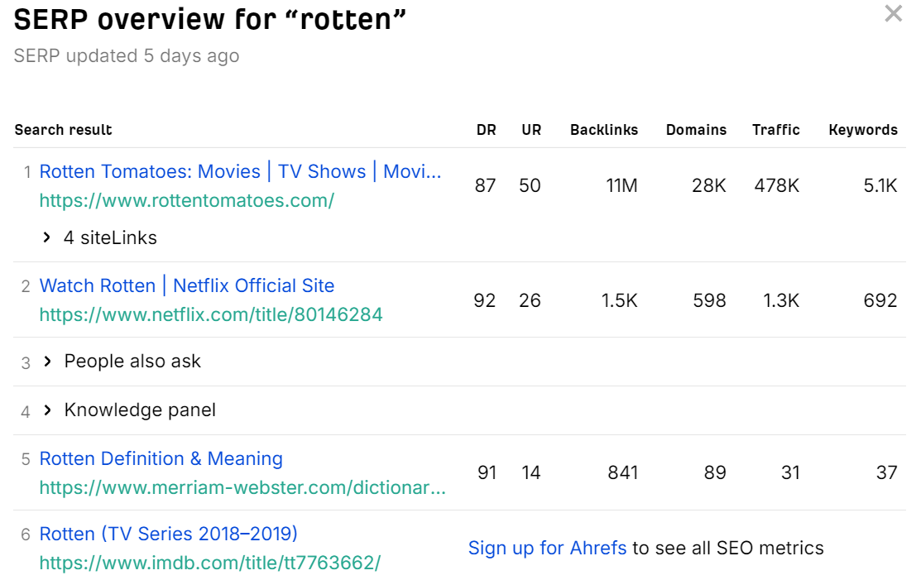

Figure 1: SERP overview for "rotten" (22/01/2024)

If the website is searched just by “***tomatoes***” (which is again a common English word) the website is in sixth position; not bad since the website has been searched by just a common word.

Then the website has been searched with other keywords that represent the content provided by Rotten Tomatoes. These searched keywords (with the relative position in SERP) were:

* “***film reviews***”: 2nd
* “***TV show reviews***”: 3rd
* “***best film***”: 3rd
* “***latest movies***”: 4th
* “***most popular TV shows***”: 8th
* “***movies in theatres***”: 5th
* “***matrix reloaded***”: 5th (tested with a real movie name)
* “***the big bang theory***”: 8th (tested with a real series name)
* all the tried combinations with the keyword “***news***” never returned the website in the top ten of SERP.

Overall, the website is well indexed in the SERP and more time the website holds these positions more users’ flow it has.

# **3 Homepage**

There is a parallelism between a shop and a website, both tries to impress people by showing what they offer in their big windows.

A shop fails if it is not able to capture the curiosity of potential customers and so its flow is not so great. This is similar on what happens on the web.

The homepage of a good website should attract people; it’s the window of the shop and if the first visit goes not so well the website has failed and users’ return rate goes down. This is the reason why the homepage is so important for websites.

This section critically analyses the homepage of Rotten Tomatoes website (**Figure 2**) considering different usability factors.

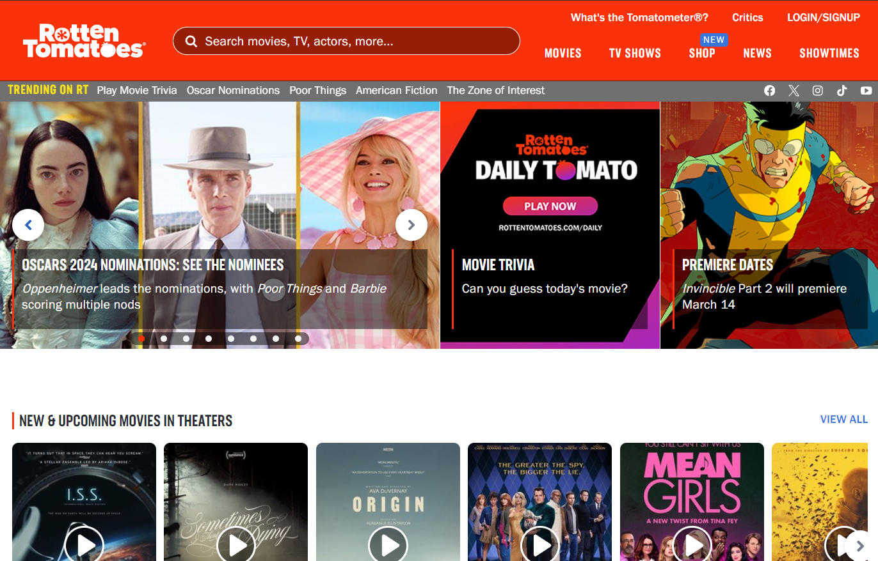

Figure 2: Homepage

## **3.1 Informative axes**

The informative axes provide a way to understand if the main information is clearly presented in the pages of websites.

In fact, users try to extract this information from the page of a new website and if they are not able to get it, they generally prefer to go away. If a user chooses to stay or not only depends on how simple the page is to read.

The informative axes are six: WHERE, WHO, WHY, WHAT, WHEN and HOW. Each of the following sections critically analyses each axis.

### **3.1.1 WHERE did the user arrive?**

There are several voices in the menu, section titles and news (visible in **Figure 2**) which remarked that a user is arrived in a website that talks about movies and TV shows. This is good because a user can easily understand in which kind of website he landed.

A user should also be conscious about his relative position on the website and it’s for this reason that a breadcrumb should always be present. In the homepage there is no breadcrumb, this could be acceptable since the homepage represents the first page of a website but in the deep linking scenario this is crucially important. In the internal pages analysis this fact has been considered deeply.

### **3.1.2 WHO is behind the website?**

Knowing the author of a website increases the users trust factor and this is not a superficial element, websites must consider it.

In the first part of the homepage (**Figure 2**), apparently, there are no information about the authors of the site; the logo does not give any useful information for new users. If the page is deeply analysed, there is a voice that contains the WHO information which is the top right link “What’s the Tomatometer®?” (visible in **Figure 2**); a bad choice because new users, that never really heard about Rotten Tomatoes, cannot know what the “Tomatometer®” is. Since the time is limited and precious, users do not try to get the WHO axis by a link that seems to not represent what they are looking for. Common users try to get this information searching in other zones of the homepage and, if the homepage is scrolled until the end, it turns out that the WHO axis is placed in the footer (**Figure 3**).

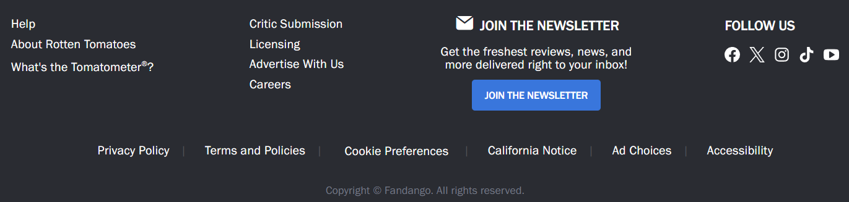

Figure 3: Footer

The highlighted box in **Figure 3** shows where the WHO axis is exactly placed: in the footer on the voice “About Rotten Tomatoes”.

Typically, new users scroll the homepage by 23% of its size so they typically never arrive to this information which is therefore badly placed.

It is also possible to note that clicking on “About Rotten Tomatoes” link a user arrives exactly in the same page of the link “What is the Tomatometer®?”, previously discussed. In fact, this link points to another section of the same page of “About Rotten Tomatoes” link.

Apparently, authors give more importance to make clear which is their measure of judgment instead of explaining who Rotten Tomatoes is. This behaviour can be related to the fame of the website, but this in fact disadvantages new users.

### **3.1.3 WHY should the user stay?**

A well-designed homepage should persuade new users to stay on the website by showing them the advantages they would obtain continuing the navigation on the website.

Watching the homepage with and without scrolling this information seems to be missing. The homepage provides different ways to get information about movies, TV shows and news about them but there is no written motivation by which a user should stay on the website. Again, this can be related to the fame of Rotten Tomatoes and so authors may think it is not necessary to explain, for instance, why their movies/TV reviews are the best ones. In fact, this disadvantages new users, who never heard about Rotten Tomatoes, since they do not have any reason to stay.

### **3.1.4 WHAT does the site offer?**

From the homepage (**Figure 2**), particularly from the menu placed in the top part of the page, it is clear what the website is offering to users. Rotten Tomatoes provides information about movies, TV shows and news related to the cinema world. What is not so clear is that Rotten Tomatoes provides reviews of movies/TV shows.

Beyond the menu (which is deeper discussed in **3.2 Menu**), the WHAT axis can be also recovered by the main section titles in the homepage content (“New & Upcoming movies in theatres”, “Popular streaming movies”, “New TV this week” and so on) and by the latest news carousel placed on the left side under the menu.

Users who stay on the website will be able to know about the past and upcoming movies, TV shows and all the latest news.

### **3.1.5 WHEN? Is the website up to date?**

A user should always be able to understand if a website is up to date or not. The WHEN axis gives an answer to this question: a website should always provide latest news/contents.

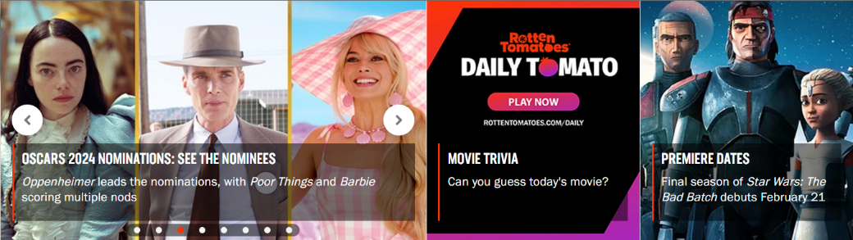

Figure 4: News section in the homepage

The homepage provides two different ways to get the WHEN axis:

1. **a specific area under the main menu** (**Figure 4**) that shows to users the latest news uploaded on the website. The single news is formed by an image, a title and a blurb (a small summary of the news itself). All these parts are clickable and, if clicked, redirect user to the relative article page where he can get more information about the selected news;
2. **the menu voice “NEWS”** which redirects users to the dedicated news section of the website.

### **3.1.6 HOW does the user arrive where he wants?**

A user should always be able to easily navigate on the website and collect all the information provided by the website itself.

All the Rotten Tomatoes reachable pages are provided by the top menu which a user can use to easily move on the website.

There is also a search functionality which users can use to obtain information in a simpler and faster way. The search functionality provided by Rotten Tomatoes can find information about movies, TV shows and celebrities without searching manually for them. In fact, the search, if provided, highly reduces the users’ computational effort to obtain information and for this it’s really appreciated tool. The search functionality is deeper discussed in **3.3 Searching**.

## **3.2 Menu**

The purpose of a menu is to show to users all the possible destinations, all the reachable pages of the website which a user can visit to collect the information provided by the site.

Rotten Tomatoes provides a menu which is placed in the top part of the homepage, as show in **Figure 5**. The menu is correctly placed since it is immediately visible from users who land on the website.

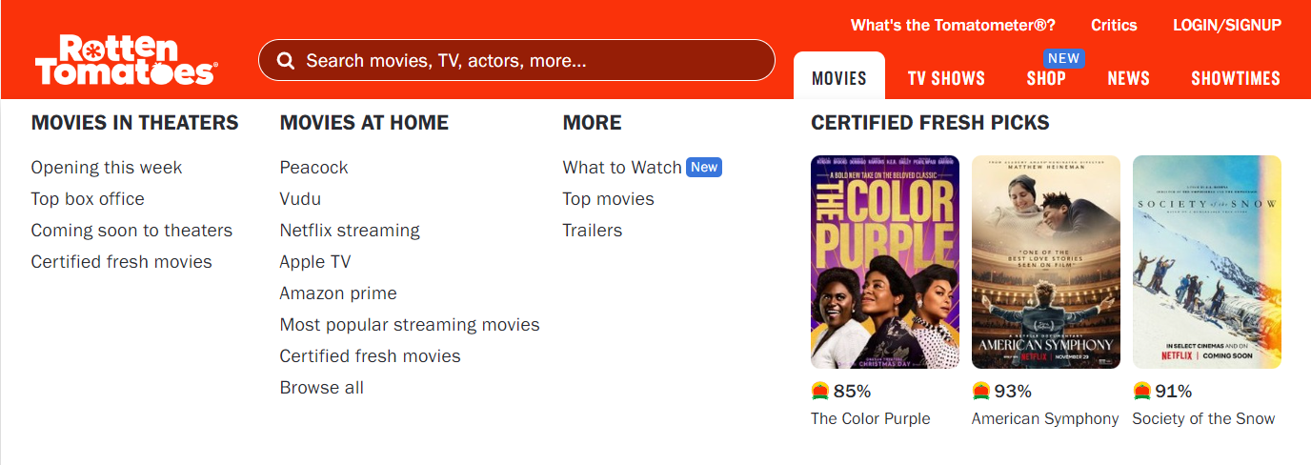

Figure 5: Menu

The menu is formed by five voices: “Movies”, “TV Shows”, “Shop”, “News” and “Showtimes”. Each menu voice represents one of the five macro areas of the website, then each area is a collection of pages related to the higher level of the tree shape of the website.

Excluding the menu voices “Shop” and “Showtimes”, if a user points the mouse cursor over one of the other menu voices a new area is displayed, as shown in **Figure 5**. This kind of sub-menu shows a small preview of the contents provided by the menu voice on which the user landed with the mouse cursor.

This implementation is interesting because a user can get a preview of other webpages contents before visiting them and, eventually, he can directly visit deeper pages provided by this new sub-menu.



Figure 6: Usability problem in the menu

Anyway, this sub-menu has a usability problem that can annoying users. In fact, if a user is interested in one of the links provided by this new menu he typically follows the fastest path to reach what he wants. These paths, to certain sub-menu links, are represented by all the red lines in **Figure 6**. The links positioned on the centre/right area has no problems (normal red lines) but the more left positioned links (represented by the dashed red lines) are never reached because the sub-menu will close itself before the user reaches the link of interest.

This happens because, to keep the sub-menu opened, the user should move down the mouse cursor until he reaches the beginning of the new menu area and then, if he remains inside this area, he can follow whatever direction he wants to reach the links.

This behaviour increases users’ computational effort to use the sub-menu functionality and it is known that users prefer easy things, represented by the normal red line ideal paths.

Another aspect badly handled is related to the “SHOWTIMES” menu voice, which enables users to book cinema tickets. This feature is only available in the United States so users who try to access to that feature outside the American region will see an error page that tell them about the problem. This is not appreciated because user expectations are broken and if a functionality is available in just one country, it must appear just on users who navigate in those countries.

## **3.3 Searching**

As already mentioned above, Rotten Tomatoes provides a search functionality that is highly appreciated by users because they can gather information simply by searching for what they want without going through many internal pages. The search-bar is well placed in the top part of the homepage (**Figure 2**), in this way it is more visible by incoming users.

Anyway, it is possible to observe that the search-bar does not respect the web standard which corresponds to a “search” label on the left and a search button (typically an icon) on the right. In fact, the search button on the left, as in this case, creates a delay of 2 seconds and on the web every second is precious. For this reason, the choice of design used here is not so effective.

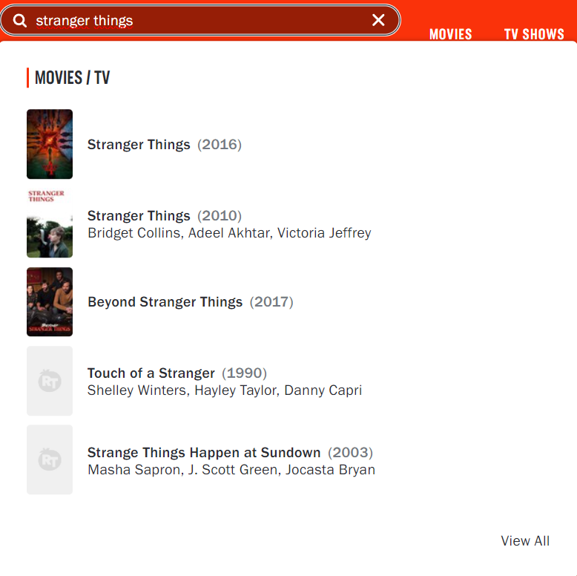

Figure 7: Search functionality in the top menu

In particular, the search allows users to search for information about movies, TV shows and actor/actress. As the user types, the search bar displays partial results matching what the user has typed up to that point (dynamic search); this is much appreciated since it helps users to find what they are looking for. So, users can click on the suggested links (both image and text are clickable) or they can press the search button to view all the results.

A curious observation is that the search is available in every page in the top menu, which users appreciates because they can use it wherever they are; but the search design and behaviour are not the same across all the Rotten Tomatoes webpages. In fact, the provided search in the “NEWS” page and all its subpages is completely different, as it is shown in the **Figure 8**.



Figure 8: Search functionality in NEWS page

As it is possible to observe, this other search respects the web standard compared to previous discussed version which all the other pages, that are not subpages of the NEWS area, provides.

On the other hand, this second version does not provide any suggested link mechanism with partial information digited (static search); it has an upgraded design but a downgraded behaviour. The main question about this choice is just “why?”. Also note that the purpose of the search is the same of the homepage version: search for movies, TV shows and actor/actress. There are no valid reasons to provide the same functionality which is presented in different ways and with a different behaviour. This just confuses and disorientates users. A bad choice of implementation.

Talking about the search-box, the recommended average length is 30 characters, in fact this measure satisfies 90% of users. Over the years the number of keywords entered by users to search for something has increased; so, websites that provide a search must be careful about the length of the search-box which should not be a random number.

The dynamic version of the search (**Figure 7**) has a length of 42 characters while the static version (**Figure 8**) has a length of 37. Both versions provide a good length, and users appreciate that. Beyond these numbers, the digited content is not entirely visible and users must scroll to see what they have written in the hidden part; since the two lengths follows the average search-box length this is not a problem.

The search results page provides all the related results divided by topics, for instance: franchises, movies, TV shows and celebrities. Each topic represents a list which is ordered from the most relevant result to the less one. This layout helps users to find what they are looking for, if present, without wasting so much time.

## **3.4 F-shape scanning**

The F-shape pattern refers to the typical eye movement pattern that users exhibit when scanning a webpage. The pattern is characterized by users scanning the content in a manner that resembles the letter "F".

The webpage is scanned in the following order:

1. First, users move their gaze horizontally to scan the top of the page. Thus, they create the upper bar of the F.
2. The second step is to move vertically, stop at a point of attraction and continue reading horizontally for a shorter stretch than the first. Here is the second bar of the F.
3. User concentration remains focused on the left side, searching for possible points of attraction which are scanned in a horizontal movement that covers a shorter area than the previous horizontal scan.

The F-shape pattern highlights the importance of placing crucial information in the most visible areas of the webpage, in order to quickly capture the users’ attention.

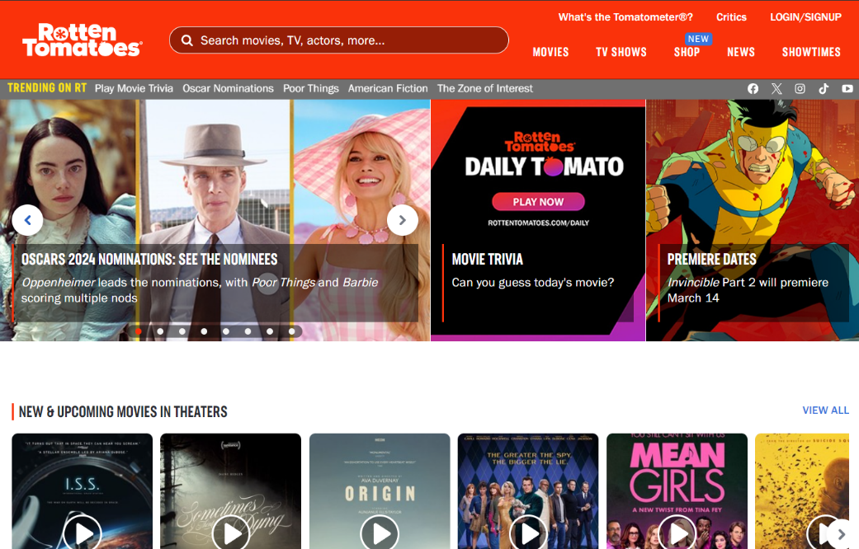

**3**

**2**

**1**

Figure 9: F-shape scanning on the homepage

The **Figure 9** provides a simulation of the F-shape reading pattern on the homepage of Rotten Tomatoes.

Users start to scan the homepage from the top-left corner (the typical entry point of a website) where there is the Rotten Tomatoes logo; this is important because the logo of a website represents its identity, and it should be the first element that a user sees when he lands on a website. Beyond the logo users scan the entire top area of the page so it is important to choose appropriately the information to place here. Rotten Tomatoes does it by placing the search, the menu, and other interesting links. In this way, by the first horizontal line of scan, a user obtains the identity of the website, the presence of the search (which can help him) and the main pages of Rotten Tomatoes website.

More the user moves down in the page less long the horizontal reading lines become; so, it is crucial to place the information in a way where the most important parts are always reachable.

In the case of the homepage a user can capture the main information also with a partial horizontal line. In fact, it is possible to observe that the second and third horizontal lines, as shown in **Figure 9**, capture the main content of the relative content sections. From the second horizontal line a user can get almost the whole WHEN information and with the third one a user can get the relative section title, a possible entry point.

When the first part of the homepage has been entirely scanned, the user can scroll the homepage to reach the remaining parts. Every new scroll leads to a new F-shape scan which reiterates the whole procedure.

Overall, the entire homepage content follows the F-shape reading pattern and this is much appreciated since the layout of the content follows one of the most used reading patterns by web users.

## **3.5 Scrolling**

Another usability problem is related to the scrolling. In fact, this operation requires computational effort and for this reason it is better having not so much scroll on the provided pages. On average, users are used to scroll 1.3 “screens”, they hardly see what there is beyond.

There are two types of scrolling: vertical and horizontal. The vertical scroll is the best one since it is the most used in the web navigation. The horizontal scrolling is to avoid at all costs because it is uncommon; in fact, it introduces a new axis to manage, and this leads to more computational effort requested by users.

The Rotten Tomatoes homepage requires 8-10 vertical scrolls to be entirely seen; this is not so effective since the homepage is long and the computational effort required to see it entirely is high. The problem is not about big images that occupy great portions of the screen, which is a persistent problem on the web, but on the quantity of content that the homepage provides. It is also true that a user can obtain the main information of the homepage by the first 2-3 scrolls and then it is his choice to continue or not the inspection. The homepage in fact is just a big summary of the internal pages, with different lists of movies and TV shows in tendency in that moment; for instance, a list of movies currently available in theatres, a list of TV shows available on a specific streaming platform and so on. This “lost” information, over the 2-3 scrolls, can be recovered inspecting internal pages where users generally scroll more, on average about the 42% compared to the 23% of the homepage.

In the maximized browser window there is no evidence of the horizontal scroll but if the window is reduced, then the horizontal scroll appears (for instance with 980px x 700px). This is bad because users who works on the web with a not maximized browser window has to manage a bidimensional space. In fact, a user has to scroll also the horizontal axis to see what there is beyond the frizzed horizontal part.

## **3.6 Text**

The text is another important aspect to consider when talking about usability of a website. The provided text should not be too much in term of quantity, since users have a limited amount of time; it should be also readable and clear.

The Rotten Tomatoes homepage does not provide so much text, so this is good in term of quantity. The text is readable since it is well written and the font used is quite standard.

The text is not resizable, in fact this can disadvantages some users who are not comfortable with the provided size.

The contrast is quite good, in fact there is a classic black text over a white background so users should be able to easily read it.

## **3.7 Visual metaphors**

The visual metaphors problem is related to some website elements on which a user has not expectations since he is not able to understand their meaning or functionalities; if these elements cannot provide any useful information, they become useless, and users avoid them.

Rotten Tomatoes has some visual metaphors which are not directly explained where they appears; in fact, the most important information, a visual metaphor, which Rotten Tomatoes website provides becomes useless.

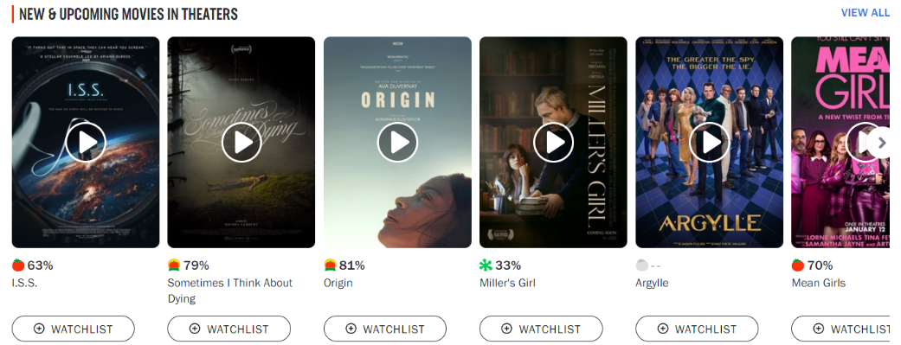

Figure 10: Instance of visual metaphors in the homepage

The **Figure 10**, extracted by the homepage, shows the nature of the problem. It is possible to note that every product reviewed by Rotten Tomatoes, a movie or a TV show, is associated to a specific percentage with a relative icon. This percentage/icon couple surely has a meaning since it has been inserted in the content of the page; so, the question that a user who never heard about Rotten Tomatoes make itself is “*What does this information means? What is it?*”. Users try to search around for some explanation without finding anything.

The answer is provided by a link inserted in the top of the page called [“What is the Tomatometer®?”](https://www.rottentomatoes.com/about#whatisthetomatometer) (visible in **Figure 5**). If a user clicks on this link, he discovers the meaning behind these mysterious percentages and icons. In synthesis these visual metaphors represent the quality of a product in Rotten Tomatoes’ opinion by showing a red tomato when a product is sufficient and a rotten tomato when the product is disappointing. The tomato is a metaphor which represents the freshness of a product, a good film is fresh and a disappointing one is rotten. It sounds great, finally the explanation appeared, but it is not so great.

In fact, users who have never heard about this website, and so about the famous “Tomatometer®”, typically do not click on this link because, as discussed in “**3.1.2 WHO is behind the website?**”. Since the time on the web is limited and precious users do not spend time over a link voice that seems to be useless.

There is also to note the crucial importance of the page “What is the Tomatometer®?”. In fact, this page provides precious explanation to better understand the content of the site, with much more icons used in the website compared with the ones shown in **Figure 10**; so, if this page is skipped, it creates a chain reaction that can lead to a losses of new potentially users.

Again, this behaviour can be related to the fame of the website but in fact disadvantages new users.

All the other visual metaphors present on the website, not just used by Rotten Tomatoes (e.g., the social media ones), are easily understandable by users.

## **3.8 Asking for personal data**

The first time on which users visit the website by passing through any page, a large cookie banner appears on the bottom part of the page, as show in **Figure 11**.

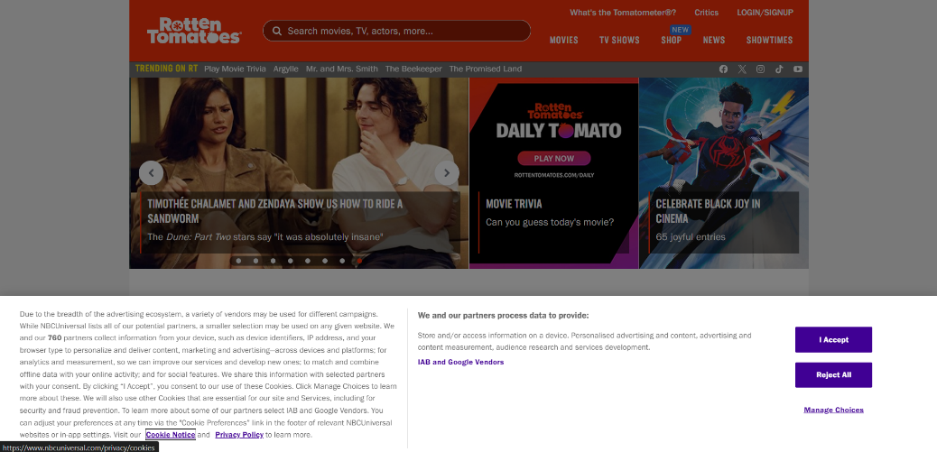

Figure 11: Cookie banner for the first visit

All the web elements as pop-ups, alerts or banners are hated by users because they are distractive elements; in fact, a banner, as in this case, is placed between the user and the content of the webpage. The time that a user takes to close the banner is subtracted from the already limited time which a user spends on a website, if the user chooses to stay.

At least in this case, the modality to close the banner, “Reject All” button on the right side, is simple but the banner is too invasive and can surely annoy many users.

Rotten Tomatoes also provides the login/signup and newsletter functionalities, but these are user’ choices and the website does not force him to subscribe on Rotten Tomatoes in any way.

The login is useful to unlock functionalities like the one provided by the “+ WATCHLIST” button in **Figure 10** which enables users to create their own personal watchlist with movies and TV shows present on the website.

Another interesting functionality, available just for registered users, is the possibility to write your personal review of a specific Rotten Tomatoes product. This personal review is averaged with all the other users reviews to create the so-called “Audience Score”. Rotten Tomatoes found an effective way to involve users, creating a community, who can be part of the website itself.

## **3.9 Video player**

If correctly used, videos can power up a website since they provide a source of information with almost a zero computational effort required by users.

As mentioned before, part of the homepage is a big summary of the reviewed products which a user can find on the Rotten Tomatoes website. These products are divided in different lists (like the one in **Figure 10**) as “Movies”, “TV shows”, “Now in theatres”, “Now in streaming” and so on.

For each element in these lists Rotten Tomatoes also provides a short trailer. In particular, from the **Figure 10**, it is possible to note a video player icon which, if clicked, make it appears a small window which shows the trailer of the relative product.

Talking about the icon which make it plays the video, there is no problem with visual metaphors because the chosen icon is quite standard on the web and so, a general user can expect a video to play.

A more in-depth discussion can be made on the type of the video player used.

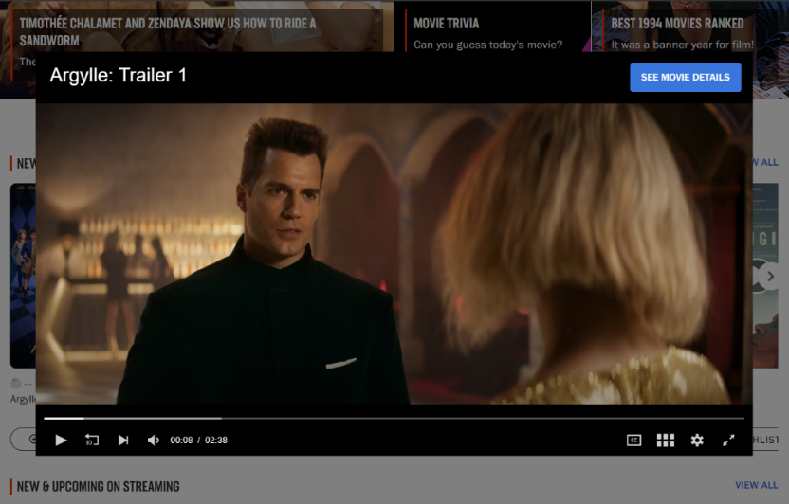

Figure 12: Video player

Once the user has clicked on the video player icon, a new window is displayed, as shown in the **Figure 12**.

Rotten Tomatoes provides its own version of the video player instead of using a non-proprietary mechanism like the one provided by YouTube. In some websites, which do not own the resources to also manage the video sharing, using proprietary mechanisms could be a problem because videos can have a delay or users are unable to manage them properly. The video player provided by Rotten Tomatoes does not have these types of problems. There are no long loading times since the video player reproduces the content considering users’ constraints, as the network features.

The controls are quite standard, with icons and functionalities that are also available in the most used video players. In fact, a user can easily stop and resume the video, turn up and down the volume, watch the video in full screen size and so on.

As it is possible to observe in **Figure 12**, there is an interesting button named “SEE MOVIE DETAILS” which redirects users to the Rotten Tomatoes movie page with all the detailed information about the product. This is well handled since if a user is interested in a product after seen the trailer, he can directly land on the product page which better describes the movie or TV show.

What is not so effective is the way to close the video player. If the **Figure 12** is observed, apparently there is no icon/way to close the video. This can confound users who, since they have no idea on what to do, typically just close the page or press the back button; in fact, these operations are the once with the lowest computational cost and so, for users, close the page is the easiest alternative compared with try to understand what to do when this is not explained. The “Rotten Tomatoes correct way” to close the video is to click out of the video player but this behaviour is not so intuitive, and it can annoy some users.

# **4. Internal pages**

This section proposes a critically analysis of the main internal pages of the Rotten Tomatoes website. In detail, the internal pages discussed are the following:

* the menu voices: MOVIES / TV SHOWS, NEWS;
* the single pages: MOVIE, TV SHOW;
* the handle of the 404 error.

Due to the reasons already discussed in **3.2 Menu**, the menu voice “SHOWTIMES” has not been considered in this section.

## **4.1 Movies and TV shows**

Since the webpage under the menu voices “MOVIES” and “TV SHOWS” is the same with just different filter options applied, these menu voices have been considered together in the analysis (as a single webpage).

The webpage “MOVIES / TV SHOWS” (**Figure 13**) represents the collection of all the movies and TV shows reviewed by Rotten Tomatoes during the years and for which a user can find the related information.

Since the reviewed products are many, Rotten Tomatoes beyond the search which remains available in the top part of the page, provides some filter options. In this way users can easily find what they are interested in by different product features.

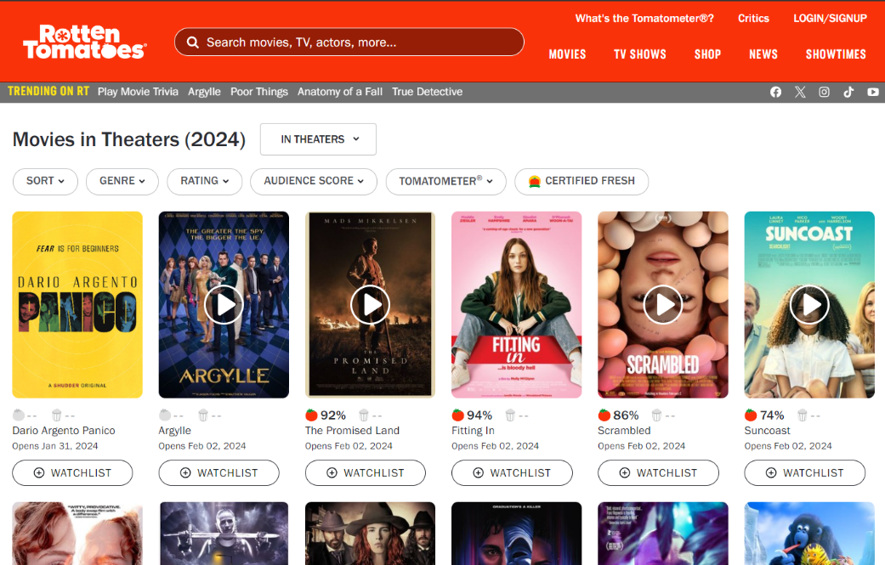

Figure 13: Movies/TV shows webpage

### **4.1.1 Informative axes**

Since in our days the navigation on a new website can start from every page (homepage or internal ones), websites must consider that users can view internal pages before the homepage. Since this scenario can happen (think about what the search engines do with indexing) even the internal pages must provide to users the main information about the website, similarly to the homepage.

As discussed before with the homepage, this information is represented by the six informative axes. Different from the homepage scenario, in internal pages some axes become mandatory and others completely optional, but, if present, users always appreciate them.

#### **4.1.1.1 Mandatory axes**

**WHERE** From the menu voices and the content of the page it is clear that a user arrived on a website which talks about movies and TV shows.

Since this page represents a possible deep linking scenario a breadcrumb is necessary to make user know about his relative position on the website. Here there is no breadcrumb and this can lead to the “lost in navigation” phenomenon.

**WHO** Here there is the same problem discussed about the homepage and related to the wrong choice of name link “What is the Tomatometer®?” (better discussed later) which is ignored by users. In fact, users who never heard about Rotten Tomatoes cannot get the WHO axis by that link so, they try to search in other parts of the page without finding anything. The answer is again placed in the footer under the voice “About Rotten Tomatoes”.

**WHAT** The global offer can be extracted from the menu voices by which it is possible to understand that Rotten Tomatoes provides information about movies, TV shows and latest news about the cinema world. What is not so clear is that the website talks about reviews, in fact this information can be extracted by the filter options but only if the user tries to use them and so not during the scanning phase.

Talking about the local offer, this page provides a list of the latest movies still available in theatres. The page provides also other movies but the first time a user lands here, just the ones currently available in theatres are visible.

#### **4.1.1.2 Optional axes**

**WHEN** As it is possible to observe from **Figure 13**, there are several textual contents which claim the temporal aspect. In fact, this information can be retrieved by the title of the page and the dates under each product in the displayed collection.

**WHY** The website does not try to persuade new users to stay on Rotten Tomatoes with any written motivation. As discussed for the homepage scenario, this behaviour can be related to the fame of Rotten Tomatoes in the television community but again, this disadvantages new potential users.

**HOW** This page is easily reachable by clicking either on the voice “Movies” or on the voice “TV shows”, both located in the main menu, available in the top part of the page. If a user wants to reach other pages, he can easily use the top menu or the links present in titles of the movie/TV show to reach the detailed page.

### **4.1.2 Structure and functionalities**

The “MOVIES / TV SHOWS” page presents the collection of the all the products reviewed by Rotten Tomatoes, presenting them in a grid of elements. Typically, the grid layout tends to confuse users due to the non-linear path to explore the contents but there is also to note that Rotten Tomatoes provides a movies/TV shows database very populated, so using a list layout is not a good choice since the page will become longer and with a higher computational cost to scroll.

Since the products are a lot, at the beginning of the page there is also a filter functionality able to show products under certain conditions as: currently in theatres, available at home, coming soon, TV shows, genre, streaming platforms and so on. This functionality is useful for users because it saves much of their time and, as previously observed, this is a fundamental aspect to consider.

Also in this page, as discussed in **3.9 Video player**, there are some grid elements which present the video icon that, if clicked, opens the same video player already talked about.

### **4.1.3 Visual metaphors**

As discussed in **3.7 Visual metaphors**, in part even this webpage suffers about the visual metaphor problem. In fact, as it is possible to observe from **Figure 13,** similarly on what happens in the homepage, every product in the grid collection is associated with a percentage and an icon. This information is not directly explained where it appears but, differently from the homepage, in this case there are further considerations to do.

There is to note that the already discussed menu link “What’s the Tomatometer®?” is available also in this page and here it has a little bit of sense.

Since one of the filter options is called “Tomatometer®”, a user who does not know what it means he can discover it in two different ways, using:

1. the top menu **link “What’s the Tomatometer®?”**. This is the option that requires more computational effort since a user, who has seen the filter option called in the same way of the menu link, should move the mouse cursor from the filter menu to the top menu of the page. Anyway, this option seems to be the “more secure” one since a user can be more confident that clicking on that link he will obtain the answer he was searching for;
2. the **filter option “Tomatometer®”** (**Figure 14**). This is the option that requires less computational effort since the user is already there and he can simply try to click on that option and hope for some explanation. In fact, this is the “less secure” option since the user has no warranties if he will find the answer or not.

The same operations can be replicated to also discover the meaning of “Audience score”, another visual metaphor (**Figure 14**) that a user can exploit to filter the contents. In fact, users can find this information by the two modalities discussed for the Tomatometer®.

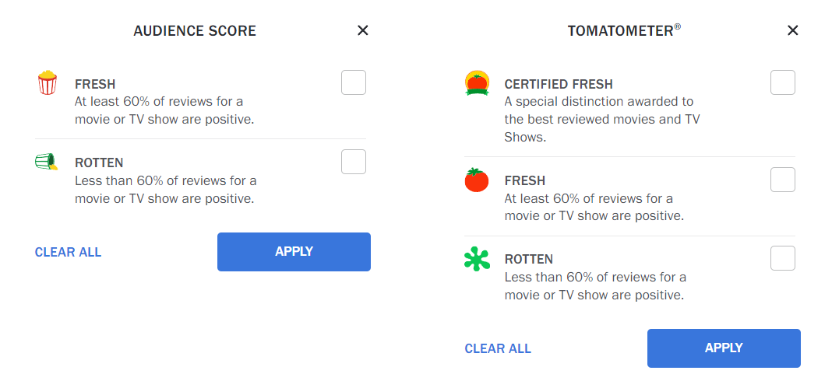

Figure 14: Visual metaphors explanation on filter options

The idea behind these icons is even interesting but the explanation is not so easy to find. In fact, none of two previously discussed modalities is effective at 100%. The visual metaphors should be intuitive or if they are not, they must be explained in the simplest possible way and here finding this information is not easy.

## **4.2 Movie**

The movie page, shown in **Figure 15**, represents the page related to a specific movie reviewed by Rotten Tomatoes. This webpage provides all the information related to the movie itself as plot, cast, videos (if present), photos (if present) and the critics/public score (if the movie has been already published by the relative film production house).

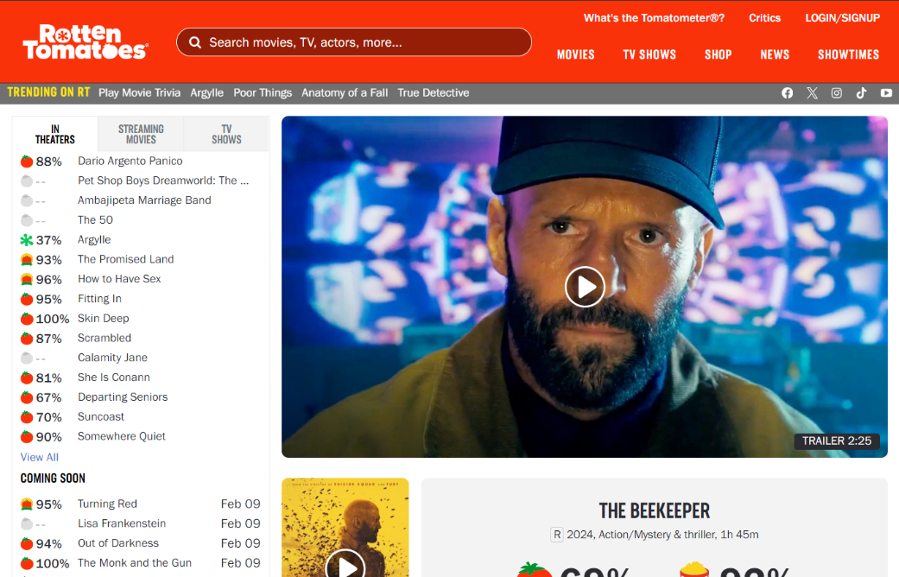

Figure 15: Movie webpage

### **4.2.1 Mandatory informative axes**

**WHERE** The menu is always a useful element to understand the content provided by the website and so the context on which it works. From the menu voices a user can understand that he landed on a website which talks about movies, TV shows and news related to the television world.

As in the movies/TV shows page, also here there is no breadcrumb which is a fundamental tool used by users to understand about their relative position on the website. Even in this case the “lost in navigation” phenomenon occurs.

For a user, it is not so easy to understand that he landed on a specific movie page since the user attention zones (F-shape scanning) are not exploited in the best of ways. In fact, after seen the top menu and all the other links in the top area of the page, the user concentration focuses on the list of movies (visible in **Figure 15**), immediately positioned on the left area under the menu. This list provides some entry points that users try to scan horizontally. In this way, the list of movies on the left obscures the content on the right. So, the content of the movie page is badly provided because the right content is never reached by users who lose the most important information of the page: movie title, other info and ratings (with the already discussed visual metaphors problem).

At the end a user, who expects to see the information about the movie he was searching for, receives as the main information a list of completely different movies from the one he wanted, creating disorientation and confusion.

**WHO** Typically, users try to get this information by the logo of a website but here the logo does not give any relevant information for users who do not know who Rotten Tomatoes is.

The problem is the same of the homepage scenario, discussed in “**3.1.2 WHO is behind the website?**”, where the badly choice for the name of the link “What’s the Tomatometer®?” makes this information hard to find. It is also true that the link, named in this way, can be useful for other elements in the page. In fact, there are some points with the expression “Tomatometer®” and since this information is not explained where it appears, a user may find the explanation searching on “What’s the Tomatometer®?” link.

**WHAT** The global offer can be extracted from the menu voices, positioned in the top part of the page. Talking about the local offer, there is the already discussed problem for the WHERE axis; in fact, for a user is hard to understand that the movie page provides information about the movie which user was looking for. There is to note that there is a huge image of the film that the page describes but, in fact, users delete all the images during the scanning phase, preferring the textual information. So, this image does not help users to understand what the page offers.

### **4.2.2 Optional informative axes**

**WHEN** The first element, which partially answer to this question, is the “NEWS” voice of the menu. In fact, a user can visit the news page to get the latest news provided by the website. Then, if the page is scrolled more than once, there are different parts on which users can recover the WHEN information; areas as the reviews one, on which a user can view the reviews trend for that movie over the time.

**WHY** This page, as the whole website, does not provide any type of motivation by which users should stay on Rotten Tomatoes. One reason, already mentioned, could be related to the fame of Rotten Tomatoes in the television community but this is not enough because new users are penalized.

**HOW** This page is not hard to reach, in fact there are different links in the homepage, and not only, that point to a specific movie page. The movie page is also reachable by using the search if a user is looking for a specific movie. If a user wants to reach other pages, he can easily use the top menu or the links present in the content of the page, as the news ones.

### **4.2.3 Structure and functionalities**

Over the content problem introduced by the list of films, the movie page (**Figure 15**) is not structured in the best of ways. In fact, even without considering the list of movies on the left, there is a problem about the order of the content.

The first element which a user sees is a huge image which, if clicked, provides the video trailer of the movie with the same modalities discussed in “**3.9 Video player**”. This element is ignored by users who do not have so much time or they just prefer to avoid videos, so this information placed at the beginning of the page is not so useful. There is also to note that the huge video player is useless because it just occupies much space of the page for nothing since the same video player is provided by the smaller image under this huge one.

Then there is the title of the film, the information about critics and public ratings, again other movies a user may like and the information about where it is possible to watch the film (theatres/on streaming).

In fact, a user who scrolls the page until this point (about four scrolls) does not have any idea about the general movie information; this information is in a section placed after all these elements. This "missed" textual information is inserted at the beginning of the page but in a video source and there are no guarantees that all users watch the video to extract this information which is therefore inserted too late in the content. Reaching this information requires more computational effort for users who are therefore not only interested in the reviews but also want to discover something more about the movie, like the plot or the cast. This should be considered.

The movie page provides also other interesting functionalities: rate/review (write your review), see videos/photos and read the latest news about the movie.

All these functionalities are well provided, even if a user should scroll the entire page to see them. In particular, the “rate and review” let users to write their opinion about the movie to create the so-called “Audience score”, already discussed before. If a user tries to write something without previously registered on Rotten Tomatoes, the login/signup window will appear, asking for personal information. This is not a problem since write or not your personal review is a user choice; he can easily close the login window and go on in the navigation.

The list of videos, if present, provides all the videos available in the site and related to the specific movie. The controls to see all the videos are standard, a classic carousel of elements with the commands to go on and back, and the video player has the same characteristics discussed in “**3.9 Video player**”. If a user is more interested in the movie videos there is also a link “view all videos” which redirect him to a specific page that contains all the videos related to that movie. All these considerations are also valid for the carousel of photos, placed under the videos one.

### **4.2.4 Visual metaphors**

Even this page suffers from the visual metaphors problem; in fact, a user who lands on this page for the first time, without facing this problem before in other pages of the site, can be a little confused when these percentages/icons appear.

There is to observe that here, differently from the homepage scenario, there is a section on which the icon/percentage couple is related to the “Tomatometer®” or the “Audience score” text. This section is placed immediately under the huge image in **Figure 15** (the image which provides the trailer); here it is possible to find the critics and the public rates, characterized by a certain percentage and a certain icon. This visual metaphor distinguishes whether the the film is sufficient or not for both critics and public.

A user can find the explanation in two ways:

1. with the previously discussed **link “What’s the Tomatometer®?”**, which remains available also in the top menu of this page. This is the operation which requires more computational effort since a user has to remember about this link and he has to move the mouse to the top menu;
2. **clicking on icon/percentage couple** of the section under the huge image in **Figure 15**. This is the cheapest operation since a user is already there and he has just to click over one of the two couples. Once a user has clicked on one couple then a new window appears. This window shows more in details the percentages about the movie for critics (Tomatometer®) and public (Audience); for each type of score there is a  icon which, if clicked, opens another smaller window which contains a partial explanation, just about the percentage and not the icon. It is possible to observe this behaviour in the **Figure 16**.

There is also to note that reaching these icon/percentage couples under the initial great image is not guaranteed since the way on which this content is placed does not follow the users’ F-shape scanning pattern. This is due to the long list of movies placed on the left side which constitutes a distracting content.

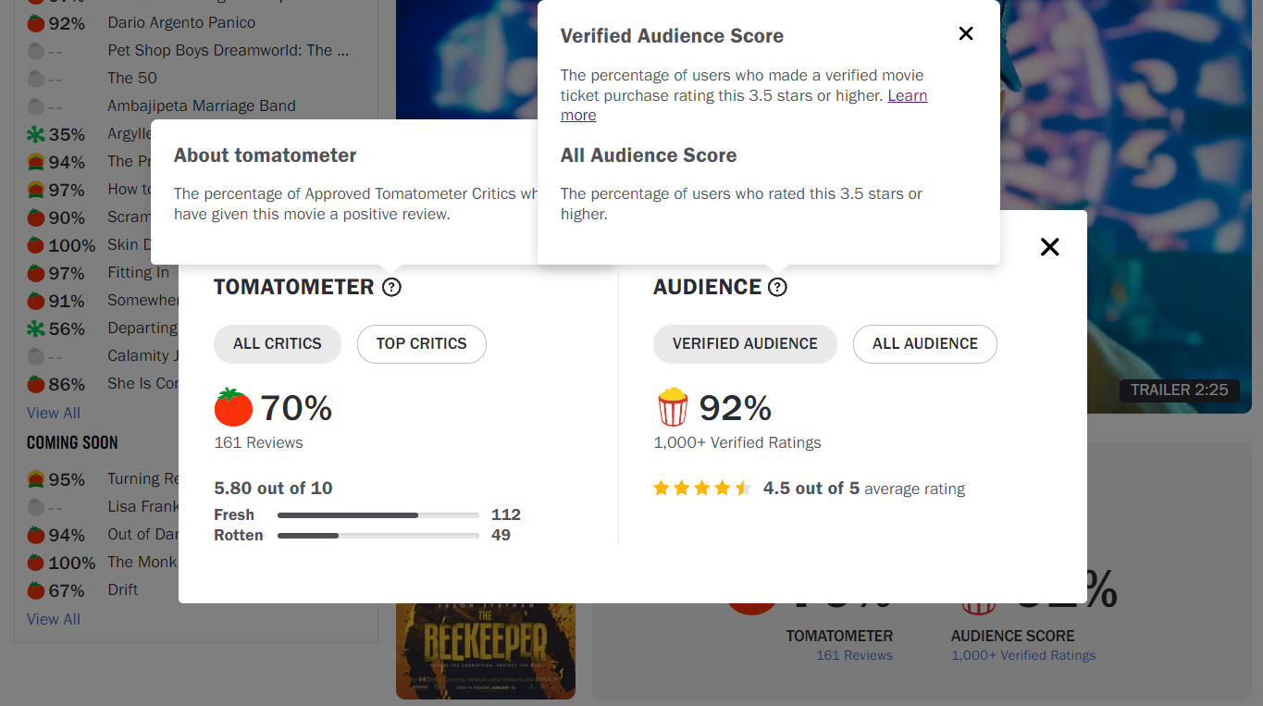

Figure 16: Visual metaphors explanation in a movie page

It is possible to conclude that the explanation can be found but not in the simplest of ways and so, the users’ computational effort on the movie page increases. In fact, the option 1 requires more computational effort while the option 2 just gives partial information so, at the end, if a user wants to obtain the complete information about these visual metaphors must use the option 1.

## **4.3 TV show**

The movie page, shown in **Figure 17**, represents the page related to a specific TV show reviewed by Rotten Tomatoes. This webpage provides all the information related to the series itself as plot, cast, videos (if present), photos (if present) and the critics/public score (if the TV show has been already published).

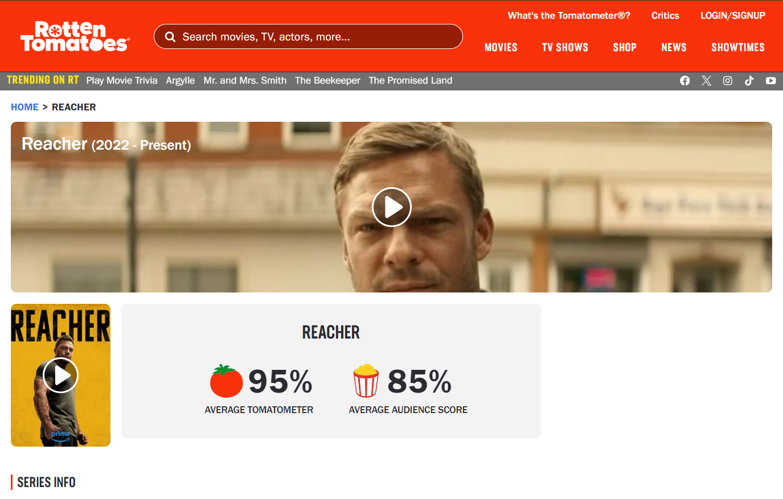

Figure 17: TV show webpage

### **4.3.1 Mandatory axes**

**WHERE** The menu partially answers to this question; in fact, a user can easily understand that he landed on a website which talks about movies, TV shows and news related to the television world.

Contrary to the previous pages, here there is a breadcrumb which helps users to better understand their relative position on the website. The interesting question is why the breadcrumb is missing in the other pages and not in this one, since it is a useful element everywhere. Considering here there is, the “lost in navigation” phenomenon does not occur.

Differently from the movie page (**Figure 15**), here for users is not so hard to understand that they landed on a page which talks about a specific series. The breadcrumb could have expressed better the user’s location by adding a “TV shows” in the middle of the path provided. Even if this is missing a user can understand that he lands on a series page and not on a movie one by observing the content of the page; in fact, there is a point of attraction called “Series info” by which it is possible to extract the context of the page.

**WHO** All the considerations, already discussed for the **WHO** axis in the movie page, are still valid for this page. There are no further elements to analyse.

**WHAT** The global offering can be extracted from the menu items, located at the top of the page, again with the problem that it is not clear that Rotten Tomatoes provides reviews of films and TV shows, certifying their quality or insufficiency. Talking about the local offer, the TV show page provides information about a specific series the user is looking for and this is understandable by user.

### **4.3.2Optional axes**

**WHEN** Apart the menu voice “NEWS”, on which a user can find all the latest news provided by Rotten Tomatoes, there are several points of the page where the WHEN axis appears (series info, seasons, news).

**WHY** As seen for the other pages, this information is missing also in this one. Rotten Tomatoes does not provide any type of motivation by why users should stay on the site.

**HOW** This page is reachable with the same modalities seen for the movie one, in fact there are different links in the homepage, and not only, that point to a specific series page. The TV show page is also reachable by using the search if a user is looking for a series. If a user wants to reach other pages, he can easily use the top menu or the links present in the content of the page, such as the news ones.

### **4.3.3 Structure and functionalities**

The structure of this page is, in general, better compared to the movie page. In fact, the series information is not provided much late in the content and this does not disadvantage users who do not already know the reviewed product; in some way the problem related to the content of the movie page here is solved. Even the image that provide the trailer of the series here is not so huge as the movie one. In fact, this image does not subtract so much space compared to the movie alternative but also this one remains useless since the same video player is provided by the smaller image under this greater one. The rating scores suffer from the same visual metaphors problem of the movie page. All the considerations discussed in “**4.2.4 Visual metaphors**” for the movie page, remain valid also for this page.

The page also provides the list and the links of the streaming platforms on which the series is available; so, a user can get the information about where he can watch the series if he is interested. There are also the same carousel of videos/photos provided by the movie page with deeper links to see all the videos/photos if a user is interested. There is nothing more to add about these tools.

What is problematic is the section “rate and review”. As discussed for the movie page, this functionality let users to write their opinion about the series to create the so-called “Audience score”. In this page, under the section “rate and review” there is just the “+ WATCHLIST” functionality which, as previously mentioned, let registered users to add a series on their own personal watchlist.

This is a problem since the section “rate and review” is wrongly named and a user expects to find a way to write his thoughts on the series, as it happens in the movie page with a form to submit.

Going deeper in the question, it is possible to discover that the reviews can be written over the single season of the series and not over the whole product. At the end of the page, there is a list of all the seasons and a user can click over a specific one to open the detailed page. In this new page it is possible to write the personal reviews with the same modality seen for the movie page. So, the original section “rate and review” is not well managed since it is not explained why a user is not able to add his review.

At the end of the page there is also a section which contains the latest news about the product. If a user is interested to read more news there is also a link “View all *series_name* news” which redirect user to the more detailed page which contains all the news related to that series.

## **4.4 News**

The news page, shown in **Figure 18**, represents the editorial of Rotten Tomatoes, an entire area of the website which focuses on providing the latest news of the cinema and television world.

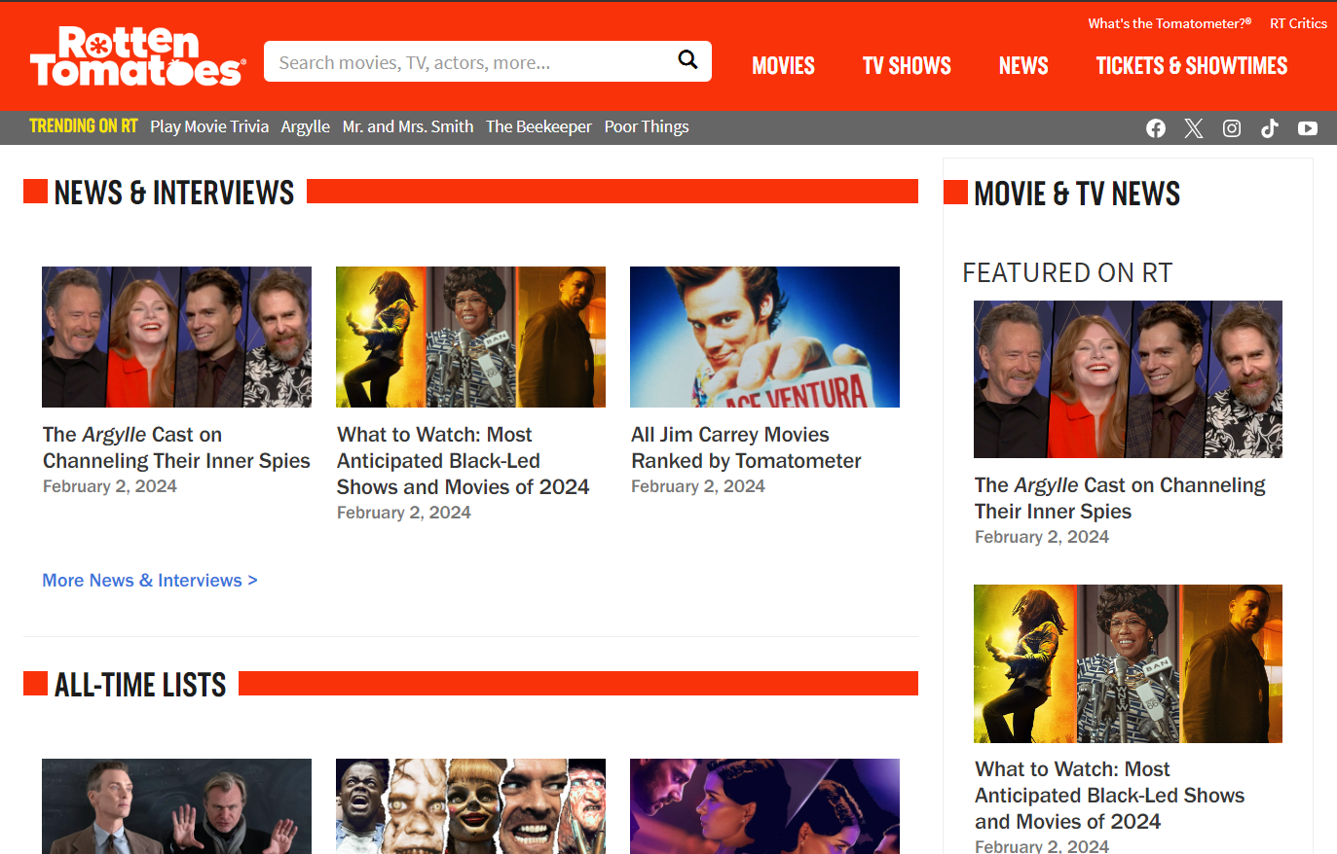

Figure 18: News webpage

It is possible to note that the domain name is different from the previous one, in fact here is: “editorial.rottentomatoes.com”. This does not represent a potential problem for users since the original domain “rottentomatoes.com” is a substring of the new one so a user can easily understand that is still on Rotten Tomatoes website. In fact, also the layout is like the pages under the main domain.

### **4.4.1 Mandatory informative axes**

**WHERE** The menu is always a guarantee; in fact, a user can easily understand that he landed on a website which talks about movies, TV shows and news. More in detail, the content provided by the page is clear. The keyword “news” is repeated several times, both in sections and in the links.

Even here there is no breadcrumb which is a fundamental tool that avoid users to lost in the websites, as discussed before. Even in this page the “lost in navigation” phenomenon occurs.

**WHO** All the considerations, already discussed for the homepage in the “**3.1.2 WHO is behind the website?**”, are still valid for this page. There are no further elements to analyse.

**WHAT** The global offering can be extracted from the menu items, located at the top of the page, again with the problem that it is not clear that Rotten Tomatoes provides reviews of films and TV shows, certifying their quality or insufficiency.

Talking about the local offer, as previously mentioned, the page provides news related to the cinema and television world. These news are divided into different sections, as it is possible to note from the sections in **Figure 18**. More in detail, if a user moves the mouse cursor over the menu voice “NEWS” a new sub-menu is displayed on which it is possible to visit deeper news pages, also here divided by types (24 Frames, Binge Guide, Box Office Guru, Critics Consensus, etc.). So, a user can read what is more interested in, using the menu or the sections of the news page, without searching from the entire list of news and this is appreciated because it saves much time.

As cons, there is to observe that the menu, which is the same of all the other pages previously discussed, suffers from the same usability problem talked in “**3.2 Menu**”; in fact, if a user tries to reach the more left positioned links, most of the times the menu will close itself.

### **4.4.2Optional informative axes**

**WHEN** Since this page provides a lot of news, the temporal aspect is much present. In fact, it is possible to observe, as shown in **Figure 18**, that every news is characterized by a title and a date. Sometimes the date is also present in the title, so here a user can easily get the WHEN axis.

**WHY** As seen for the other pages, this information is missing also in this one. Rotten Tomatoes does not provide any type of written motivation by why users should stay on the site. An implicit reason could be related to all the news which are visible on the page, a proof on the quantity of information that Rotten Tomatoes provides to its users.

**HOW** The news page is reachable by the menu voice “NEWS” and all the links present in the homepage and in the internal pages, as seen before for the movie and TV show pages. If a user wants to reach other pages, he can easily use the top menu or the links present in the details of the single news.

### **4.4.3 Structure and functionalities**

The news page is structured as a list of the latest news divided for topics where each topic represents a section of the page. For each section, just the latest three news are visible and if a user is interested in other related ones, he can visit the link “More *topic_of_news*” (e.g. “[More News & Interviews](https://editorial.rottentomatoes.com/news)”).

The content is well provided since the way on which is placed follows the F-shape scanning pattern. This is important because it is the one of the most used users’ reading patterns on the web. In fact, apart from the menu which is entirely scanned as first element, the different sections titles are placed on the left as possible entry points for users who are interested in a specific category of news. The more the user reads the page, the shorter the horizontal scan becomes but this is not a problem since the section titles are not so long and always placed on the left which is the horizontal scan starting point.

The page is long and it requires a great number of scrolls, so a great amount of computational effort, to be entirely seen. There would be the possibility to use the sub-menu, which it opens when a user is over the “NEWS” menu voice. The submenu feature allows users to see the list of news topics directly in a scrolling area and can select which news topic interests them the most, avoiding scrolling the entire page. But the menu, as discussed before, has an important usability problem which can annoy users. This is a big waste of potential since the sub-menu is a useful tool considering the limited time that users have on the web but, as it stands, the sub-menu represents just a waste of users’ time.

## **4.5 Handle of 404 error**

The handle of the 404 error (page not found) is one of the typical errors on the web design. The fact that a user arrived on a page that does not exist must be clear and simple to get.

Rotten Tomatoes provides two different pages, regarding on which domain the user is searching for a page. Similarly, on what discussed for the two versions of the search, one of the two 404 solutions is better than the other.

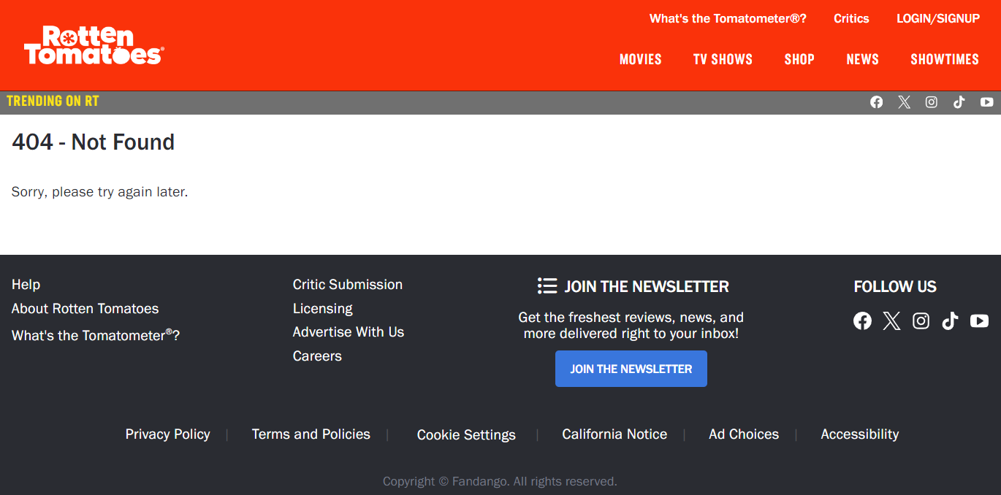

Figure 19: 404 error under the "rottentomatoes.com" domain

The first solution, visible in **Figure 19**, is the one provided by searching a page that does not exist under the “rottentomatoes.com” domain. Facing up the 404 error is a normal behaviour on the web since users can digit a wrong URL or they can try to visit a page that does not exist anymore.

Websites must explain to users what happened, otherwise they can think there is a problem with the site and users’ return rate drastically drops down. This is the scenario that happens on the 404-page provided by the domain “rottentomatoes.com”.

As it is possible to observe in **Figure 19**, there is not any explanation about the problem; users just see a number (404) and the phrase “Sorry, please try again later”. The “Help” link in the footer is useless in this scenario because it does not provide any explanation about the 404 problem.

At least, the menu is available and users can use one of the main menu options to return to a working page.

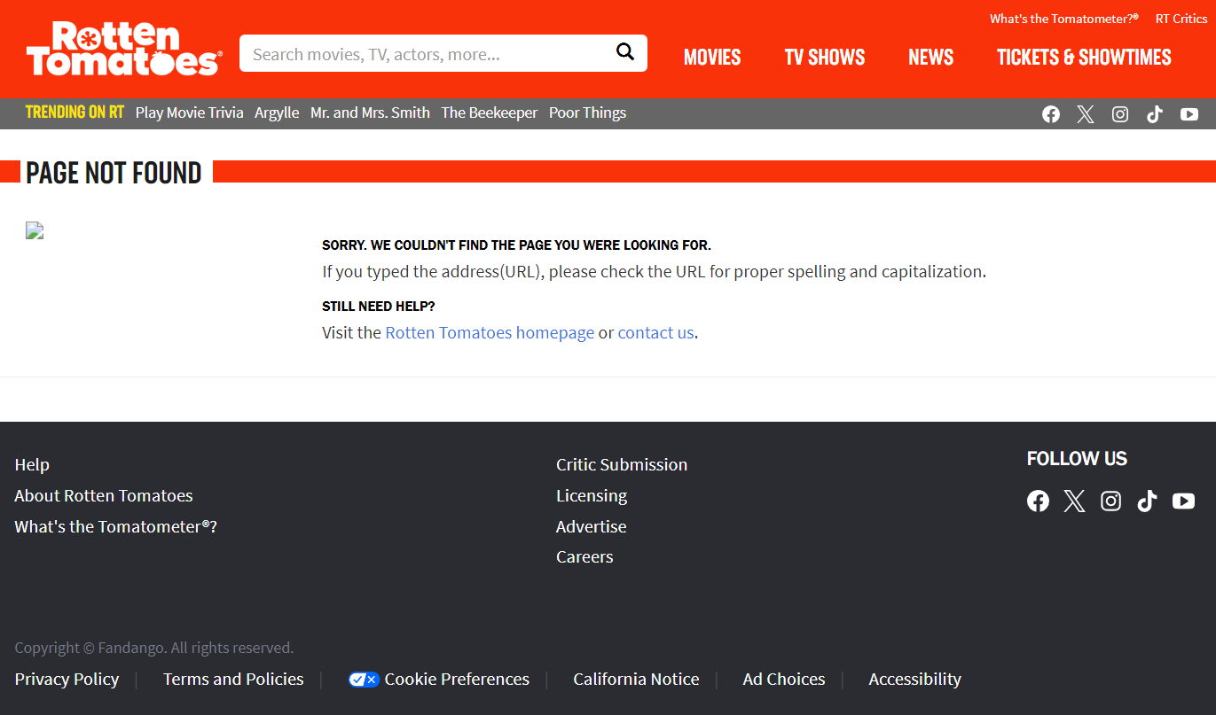

Figure 20: 404 error under the "editorial.rottentomatoes.com" domain

An improved solution is the handle of 404 error under the “editorial.rottentomatoes.com” domain. As it is possible to observe in **Figure 20**, the previously missing explanation is present and clear. Rotten Tomatoes explains the problem to users, probably related to the wrong typed of the searched web address.

The page provides a direct link to the homepage to redirect users to a working page and a link to contact the support team if the problem persists. Users are satisfied because they understand what happened and they can go on with the navigation starting from a working page. Even here the top menu is still available and working.

It is clear that this second approach works better and the question is why the website uses two different solutions when one is better than the other? It is a similar problem to the one discussed for the search where both solutions have pros and cons, so the unified version would be more effective. Here it is even worst because the “rottentomatoes.com” solution does not work and compared to the “editorial.rottentomatoes.com” approach, the first one has just cons while the second one has more pros than cons.

# **5. Final evaluation**

Overall, the Rotten Tomatoes website is not badly designed but with the discussed small improvements it could be upgraded to a better version. The information provided is interesting and great in the quantity, especially for the news area and all the products that the website covers, from the oldest to newest ones. The more serious usability problem is about the visual metaphors, in fact it has been mentioned for most of the internal pages since it is the main information that the site provides. The explanation there is but it is not simple to get, as observed.

The overall evaluation considers all the analysed pages, taking into account especially the homepage, that weights double, since it is the window that represent the entire website. The following table provides a grade (1 to 10) for every analysed page and the final evaluation to the website.

|  |  |
| --- | --- |
| **Page** | **Grade** |
| Homepage | 7 |
| Movies/TV shows | 7 |
| Movie | 5.5 |
| TV show | 6.5 |
| News | 8 |
| **Final grade** | **7/10** |